# Bitcoin Mining

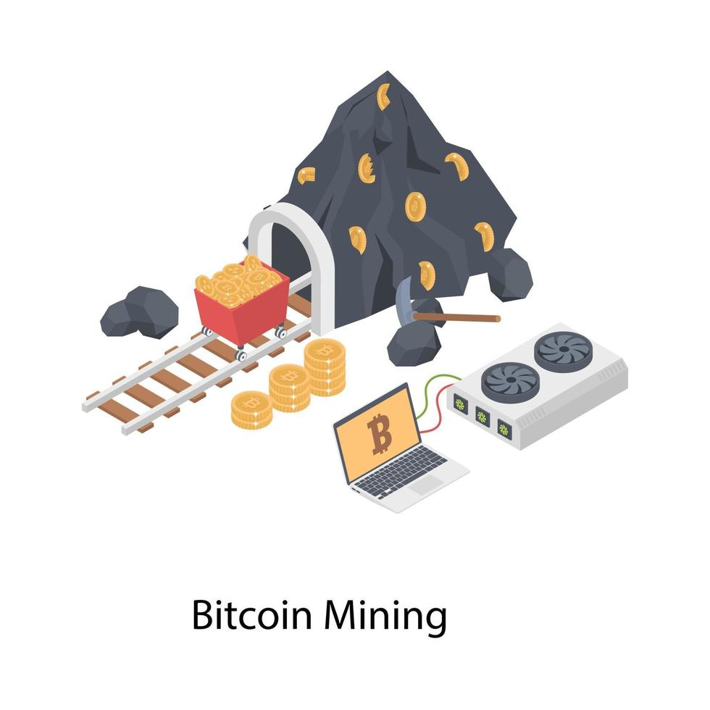

*Bitcoin mining is the process by which Bitcoin transactions are verified and recorded on the blockchain. A transaction is a transfer of Bitcoin value on the blockchain. In very simple terms, a transaction is when participant A gives a designated amount of Bitcoin they own to participant B.*

Bitcoin users can control how quickly their transactions are processed by setting the fee rate. The **higher the fee rate**, **the faster the transaction will be processed**. Each block in the blockchain can only contain up to **1MB (1 000 000 bytes) of information.**

Since space is limited, a **limited number of transactions can be included in each block**. This means **Bitcoin miners are incentivized to prioritize the transaction with the highest fees**.

Write a program that based on the block capacity, you need to decide which transactions to put in it to **maximize the fees** of the pending transactions..

## Input

* On the first line, you will receive an integer – n – number of the pending transactions.
* On the next n lines, you will receive a transaction in the following format: "{hash} {size} {fees} {from} {to}".
  + Size will be in bytes.

## Output

* Print the used size of the block in the following format: "Total Size: {totalSize}".
* Print the total fees of all transactions in the block in the following format: "Total Fees: {totalFees}".
* Print transaction hashses that will be included in the block.
  + Order doesn’t matter.

## Constraints

* n will be in the range [1… 25].
* size will be in the range [0… 1 000 000].
* fees will be in the range [0… 1 000 000].

## Examples

|  |  |
| --- | --- |
| **Input** | **Output** |
| 5  25d8dd2f 342000 23213 coinbase.btc atanasov.btc  16d27e46 542000 523213 coinbase.btc shopov.btc  6247072a 242000 13213 coinbase.btc ani.btc  fc951abc 600000 113213 procoinbase.btc atanasov.btc  0a4a5f32 450000 153213 procoinbase.btc peter.btc | Total Size: 992000  Total Fees: 676426  0a4a5f32  16d27e46 |
| 5  25d8dd2f 100000 2321 coinbase.btc atanasov.btc  16d27e46 200000 52323 coinbase.btc shopov.btc  6247072a 300000 1323 coinbase.btc ani.btc  fc951abc 150000 11323 procoinbase.btc atanasov.btc  0a4a5f32 100000 15313 procoinbase.btc peter.btc | Total Size: 850000  Total Fees: 82603  0a4a5f32  fc951abc  6247072a  16d27e46  25d8dd2f |